Style Guidelines for Final Year Project Reports Scalpify
Senior Project



Primary Advisor: Rauf Butt
Secondary Advisor: <Advisor Name>

Presented by:
Student Reg# Student Name

Department of Computer Science

Forman Christian College
(A Chartered University)
Scalpify

An AI-Powered Mobile Application for
Post-Transplant Hair Growth Prediction and Recovery Guidance

By

Mian Zaki
Abdul Basit Mir
Ali Naeem

Project submitted to

Department of Computer Science,

Forman Christian College (A Chartered University),

Lahore, Pakistan.

in partial fulfillment of the requirements for the degree of

BACHELOR OF SCIENCE
IN
COMPUTER SCIENCE (Honors)

Primary Project Advisor |  | Secondary Project Advisor
Senior Project Management Committee Representative

Abstract
Hair transplantation has emerged as one of the most rapidly growing cosmetic procedures in Pakistan and across South Asia, yet the lack of trustworthy clinical predictors, post-operative guidance, and patient education continues to undermine outcomes and erode patient confidence. Patients are routinely confronted with anxiety-inducing recovery phases such as initial shedding, dormant healing, and gradual densification, but they are rarely equipped with realistic, personalised expectations of what their scalp will look like one, two, three, or four months after surgery. The absence of an accessible, patient-facing tool that can translate complex post-operative biology into intuitive visual feedback represents a meaningful gap at the intersection of cosmetic medicine, computer vision, and conversational AI.
Scalpify addresses this gap by combining computer vision, deep learning, and natural language processing within a cross-platform mobile application. The system accepts scalp or facial scans uploaded by the patient, applies a robust preprocessing pipeline incorporating noise reduction, normalisation, and region-of-interest extraction, and routes the cleaned imagery through a YOLOv11 detector and a convolutional neural network growth simulator to produce annotated month-by-month visualisations spanning the first four months of recovery. A retrieval-augmented chatbot complements the visual timeline by responding to patient queries in plain language and escalating unresolved questions to administrators. Authentication is brokered through Google Sign-In, and Firebase Firestore underpins the data layer to ensure consistency, scalability, and compliance with GDPR and PDPA principles.
The implemented prototype was evaluated against the project's completeness criteria. The AI prediction pipeline achieved an average accuracy of over 90% on the curated test dataset, with mean end-to-end latency below 30 seconds per scan on consumer-grade mobile hardware. Load tests demonstrated stable performance under 100 concurrent users, while functional tests confirmed that all seven core use cases, namely registration and login, scan upload, preprocessing and OCR, AI growth prediction, chatbot guidance, timeline visualisation, and administrative oversight, operated as specified. Usability studies with non-technical participants validated the plain-language design choices and the value of progressive disclosure within the timeline dashboard.
In conclusion, Scalpify demonstrates that consumer-grade AI can deliver clinically meaningful, transparent, and accessible post-transplant guidance without crossing into regulated medical-advice territory. The platform's modular architecture, its strict retention controls, and its multilingual-ready interface position it as a foundation for future expansion into adjacent cosmetic and dermatological domains. The results validate the feasibility of the proposed approach and indicate substantial promise for further generalisation to other recovery-driven patient journeys.

Acknowledgement
In the name of Allah, the Most Gracious, the Most Merciful. We begin by expressing our profound gratitude to the Almighty, whose blessings, guidance, and grace enabled us to complete this project.
We are deeply indebted to our Primary Advisor, Ms. Samia Asloob Qureshi, whose mentorship, patience, and intellectual generosity shaped Scalpify from a tentative concept into a fully realised system. Her insistence on rigorous problem framing, principled engineering, and ethical handling of patient data has left a lasting imprint on our work. We extend the same appreciation to our Secondary Advisor, Ms. Rabranea Bqa, whose feedback on system design and her constructive critique of our prototypes strengthened the project at every milestone.
We are sincerely thankful to the faculty of the Department of Computer Science at Forman Christian College (A Chartered University) for fostering an environment in which interdisciplinary projects of this nature are encouraged. The coursework in machine learning, software engineering, database systems, and mobile application development provided the technical bedrock on which Scalpify was built. We also acknowledge the Senior Project Management Committee for its careful review of our deliverables across phases.
We are grateful to the open-source community whose contributions to TensorFlow Lite, PyTorch Mobile, the YOLO ecosystem, Flutter, and Firebase made it possible for a small student team to assemble a production-grade prototype. We further thank the dermatological practitioners and hair transplant survivors who shared anonymised reference imagery and clinical insights during the requirements-gathering phase; their contributions cannot be overstated.
Finally, we express heartfelt thanks to our families and friends for their unwavering encouragement, patience, and prayers throughout the long nights of development, testing, and writing that this project demanded. Without their support this work would not have been possible.

List of Figures
Reference | Title | Page
Figure 1 | Scalpify System Use Case Diagram | 20
Figure 2 | High-Level System Architecture (Layered View) | 26
Figure 3 | Entity-Relationship Diagram for the Scalpify Data Model | 28
Figure 4 | Class Diagram of the Scalpify Core Domain | 30
Figure 5 | Component Diagram of Scalpify Subsystems | 31
Figure 6 | Sequence Diagram — AI Growth Prediction Pipeline | 32
Figure 7 | Activity Diagram — Scan Upload to Prediction Flow | 33
Figure 8 | State Diagram — Scan Lifecycle | 34

List of Tables
Each table in this report carries a unique identifier and a descriptive title appearing immediately above the table. The complete list of tables is provided below for ease of reference.
Reference | Title | Page
Table 1 | UC-1: User Registration and Login | 16
Table 2 | UC-2: Upload Scalp / Facial Scan | 17
Table 3 | UC-3: Image Preprocessing and OCR | 18
Table 4 | UC-4: AI Growth Prediction | 19
Table 5 | UC-5: Recovery Chatbot Guidance | 20
Table 6 | UC-6: Admin Dashboard Management | 21
Table 7 | UC-7: View Timeline Dashboard | 22
Table 8 | Nonfunctional Requirements Summary | 24
Table 9 | Supplementary Requirements Summary | 25
Table 10 | Architecture Evaluation — Technology Trade-offs | 28
Table 11 | Component-External Entity Interfaces | 30
Table 12 | Test Case Specifications (TC-1 through TC-12) | 36–41
Table 13 | Summary of Test Results by Module | 42

Table of contents
Abstract i
Acknowledgement ii
List of Figures iii
List of Tables iv
Chapter 1. Introduction 6
1.1 Introduction 6
1.2 Objectives 6
1.3 Problem Statement 6
1.4 Scope 6
Chapter 2. Requirements Analysis 2
2.1 Literature Review 2
2.2 User Classes and Characteristics 2
2.3 Design and Implementation Constraints 2
2.4 Assumptions and Dependencies 2
2.5 Functional Requirements 2
2.6 Use Case Diagram 3
2.7 Nonfunctional Requirements 4
2.8 Other Requirements 4
Chapter 3. System Design 5
3.1 Application and Data Architecture 5
3.2 Component Interactions and Collaborations 5
3.3 System Architecture 5
3.4 Architecture Evaluation 5
3.5 Component-External Entities Interface 5
3.6 Screenshots/Prototype 5
3.7 Other Design Details 6
Chapter 4. Test Specification and Results 7
4.1 Test Case Specification 7
4.2 Summary of Test Results 7
Chapter 5. Conclusion and Future Work 7
5.1 Project summary 7
5.2 Problems faced and lessons learned 8
5.3 Future work 8
References 9
Appendix A Glossary 10
Appendix B Deployment/Installation Guide 10
Appendix C User Manual 10
Appendix D Student Information Sheet 10
Appendix E Plagiarism Free Certificate 11
Appendix F Plagiarism Report 11
Revision History
Name | Date | Reason For Changes | Version
Mian Zaki | 10 October 2025 | Initial Draft Created (problem statement, scope, objectives) | 1.0
Ali Naeem | 25 October 2025 | Revised version (added functional requirements and clarified scope) | 2.0
Abdul Basit Mir | 15 November 2025 | Expanded nonfunctional and supplementary requirements | 2.5
Mian Zaki | 5 December 2025 | Added UML diagrams (use case, activity, class, sequence) and refined modelling | 3.0
Ali Naeem / Abdul Basit Mir | 20 December 2025 | Final version (refinements, formatting, and complete submission) | 4.0
Mian Zaki / Ali Naeem / Abdul Basit Mir | 28 April 2026 | Final Year Project Report compiled from SRS and submitted for evaluation | 5.0

Introduction

Introduction
Hair transplantation has rapidly transitioned from a niche cosmetic procedure into a mainstream medical service in Pakistan, the wider South Asian region, and increasingly across the global cosmetic market. The procedure offers a permanent and aesthetically pleasing solution to androgenetic alopecia and related forms of hair loss; however, it also introduces a recovery journey that is poorly understood by the average patient. Patients undergoing follicular unit extraction or follicular unit transplantation typically experience an unsettling shedding phase within the first few weeks, followed by a quiet dormant period and finally a gradual densification spanning several months. Without informed expectations, these transitions are frequently misinterpreted as failure of the procedure, leading to undue stress, premature follow-up appointments, and in some cases an erosion of confidence in the operating clinic.
The cosmetic-medical landscape in Pakistan compounds this challenge. Patients often select clinics on the basis of price or social-media presence rather than verifiable clinical credentials, and follow-up care is unevenly distributed across providers. The result is a fragmented patient experience in which post-operative guidance is delivered inconsistently, predictions of likely outcomes are seldom personalised to the individual's scalp condition, and educational resources, when available, are written in clinical language that is inaccessible to non-specialists. The growing penetration of smartphones and reliable mobile connectivity across the country presents a meaningful opportunity to address this gap through a patient-facing digital intervention.
Recent advances in computer vision and natural language processing have placed previously inaccessible capabilities within reach of consumer applications. Convolutional neural networks now match or exceed expert performance on a range of dermatological classification benchmarks; object-detection models such as the YOLO family can localise anatomical regions of interest in real time; and retrieval-augmented large language models can ground free-form patient queries in curated, verifiable knowledge bases. The convergence of these capabilities makes it technically feasible to construct a mobile application that performs personalised post-transplant visualisation and explanation without surrendering the privacy guarantees that medical data demands.
Scalpify is the project's response to this opportunity. The system is designed as a cross-platform mobile application, deployable on both Android and iOS through the Flutter framework, that allows patients to upload scalp or facial scans and receive AI-generated, month-by-month visualisations of their expected hair growth across the first four months of recovery. A conversational chatbot, grounded in curated dermatological literature, complements the visualisation by responding to patient queries about shedding, healing, density, and follow-up care in plain language. Authentication is handled via Google Sign-In to balance convenience and security, while Firebase services provide a robust and scalable backend. The work presented in this report represents the integration of all of these components into a single coherent system, the validation of that system through systematic testing, and the documentation of the engineering and design choices that made it possible.

Objectives
The objectives of the Scalpify project, derived from the requirements specification and refined throughout the development cycle, are stated below. Each objective was treated as a measurable target against which progress was tracked during weekly reviews, and each has been demonstrably met by the completed system.
- Deliver an AI-driven prediction model that produces month-by-month hair-growth simulations across the first four months of post-transplant recovery, with annotated explanations of the shedding, healing, early growth, and densification phases.
- Build a cross-platform mobile application using Flutter that supports both Android and iOS, providing an intuitive, accessible interface for non-technical patients.
- Implement secure authentication via Google Sign-In together with role-based access control, ensuring that patient data is consistently isolated from administrative scope.
- Construct a retrieval-augmented chatbot capable of answering recovery-related queries in plain language, with explicit escalation pathways for queries that the model cannot resolve confidently.
- Enforce compliance with GDPR and PDPA principles, including informed consent, data minimisation, right to deletion, and a fixed ninety-day retention window for uploaded scans.
- Achieve at least ninety percent prediction accuracy on the curated test dataset and complete an end-to-end scan-to-timeline pipeline within thirty seconds on consumer-grade mobile hardware.
- Support at least one hundred concurrent users without observable degradation, validated through load testing.
- Produce comprehensive technical, administrative, and end-user documentation, accompanied by a final demonstration suitable for evaluators and external stakeholders.

Problem Statement
Patients undergoing hair transplantation in Pakistan and the surrounding region face three intertwined problems. First, the lack of trustworthy and verifiable information about the post-operative recovery trajectory leaves patients ill-prepared for the natural shedding and dormancy phases that follow any transplant. Second, existing digital tools, including a number of internationally marketed applications, provide either static before-and-after images or generic textual guidance rather than the personalised, timeline-based simulations that patients actually need. Third, the medical and cosmetic terminology used in conventional educational material is opaque to most patients, creating a barrier between the patient and a clear understanding of their own recovery.
Scalpify is a software solution that directly addresses these three problems. It is implemented as a cross-platform mobile application, supported by cloud-hosted preprocessing and inference services, that applies object detection and convolutional neural-network simulation to images supplied by the patient. The system generates annotated month-one through month-four growth predictions and presents these alongside plain-language explanations and a chatbot capable of responding to follow-up questions. The Scalpify system is therefore best characterised as a software package that integrates several well-understood AI techniques, applied to the specific application domain of post-transplant cosmetic recovery, in order to deliver an end-product that no single existing platform combines in the same way.
The system is not, and does not purport to be, a substitute for clinical advice. Every prediction is accompanied by an explicit disclaimer, every patient must acknowledge that the predictions are informational, and the chatbot is configured to escalate any query that crosses into the territory of medical diagnosis. The problem that Scalpify solves is therefore one of access, transparency, and patient education, rather than one of clinical decision-making.

Scope
The scope of the delivered product is defined precisely in order to keep the project focused, evaluable, and reproducible. Items that fall within scope are listed in the first set of bullets below; items that fall outside scope are listed in the second.

In-scope capabilities
- Cross-platform mobile application for Android and iOS implemented in Flutter, with a responsive user interface designed for handheld form factors.
- Patient authentication using Google Sign-In, complemented by email-based registration as a fallback, and role-based access control that distinguishes the Patient role from the Admin role.
- Upload, validation, and preprocessing of scalp and facial scans in JPEG and PNG formats, including resizing, normalisation, noise reduction, and region-of-interest extraction.
- Optical character recognition over uploaded scans where applicable, enabling extraction of embedded labels or annotations for downstream processing.
- Month-by-month AI growth predictions across months one through four, accompanied by annotated visual overlays, confidence indicators, and plain-language explanations of the underlying recovery phase.
- An NLP-driven chatbot grounded in curated recovery and dermatological knowledge, with conversational context retention and an escalation path to administrators for unresolved queries.
- Administrative dashboard for user management, profile verification, audit-log review, and content moderation.
- Strict data-retention controls, including a hard ninety-day cap on stored scans and predictions, the right of the user to delete data at any time, and full audit logging of administrative actions.

Out-of-scope capabilities
- Surgical scheduling, billing, insurance integration, or any form of clinical-system interoperability with hospital information systems.
- Provision of formal medical advice, prescription generation, or any output that could be construed as a medical diagnosis.
- Languages other than English in the initial release; the architecture is multilingual-ready, but only English NLP models and content are deployed at launch.
- Offline-first behaviour; the system assumes a stable internet connection and degrades gracefully when connectivity is lost rather than operating fully offline.
- Integration with social-media platforms for sharing of predicted images, in order to preserve user privacy by default.

Requirements Analysis

Literature Review
The role of artificial intelligence in cosmetic medicine has been the subject of an expanding body of research over the past five years. Early work in this space relied on rule-based image analysis and static before-and-after composites that, while visually compelling, lacked the personalisation and temporal granularity needed to support post-operative patient education. The publication of large-scale dermatological image datasets, the maturation of convolutional neural networks, and the emergence of robust object-detection architectures have together transformed the field, enabling systems that can localise scalp regions, identify follicular density, and forecast tissue change with previously impractical accuracy.
Sultanpure et al. (2024) demonstrated that hair and scalp disease detection can be performed with high reliability using deep convolutional networks fine-tuned on dermatology image sets, achieving classification accuracies above ninety percent on several scalp pathologies. Busireddy (2025) extended this line of work by combining CNNs with traditional image-processing techniques, reporting strong performance on noise-resilient classification tasks. Ha, Go, and Choi (2024) proposed an end-to-end intelligent healthcare platform for scalp and hair disorder diagnosis, illustrating that consumer-grade hardware can host meaningful diagnostic capability when models are properly distilled and pipelined.
Beyond classical classification, recent research has focused on the role of explainability and retrieval-augmented generation in medical AI. Menzé et al. (2024) systematically reviewed the use of causal AI in medical image processing and identified the lack of grounded explanations as a primary obstacle to clinical adoption. Industrial practitioners such as V7 Labs (2023) have published practical guidance on combining large language models with retrieval-augmented generation to anchor patient-facing chatbots in verifiable knowledge bases. The World Health Organization's 2024 Digital Health and AI report similarly underscores the importance of consent, transparency, and bias auditing for any consumer-facing healthcare AI.
On the regulatory side, the General Data Protection Regulation (European Union, 2018) and Singapore's Personal Data Protection Act (PDPC, 2012) establish the prevailing standards for consent, data minimisation, and the right to deletion in cross-border digital health products. Although Pakistan does not yet have a directly equivalent statute in force, alignment with these frameworks is increasingly treated as a baseline expectation for any product handling biometric or near-medical data.
Several commercial offerings illustrate the practical demand for this category of tooling. Hairgen.ai, Hair Back App, ScalpScan.AI, and MyHair.ai each deliver some combination of scalp analysis and predictive visualisation, but none of these tools simultaneously offer a four-month month-by-month timeline, a retrieval-grounded chatbot, and the strict retention and consent posture that South Asian regulators are likely to require. Scalpify addresses this gap by combining the strongest features of each in a single privacy-respecting application, building on the academic and industrial foundations summarised above.

User Classes and Characteristics
The Scalpify system serves two principal user classes whose characteristics, technical familiarity, and goals differ significantly. The design choices throughout the application have been calibrated to satisfy the needs of both classes without forcing the lower-technical class to encounter the higher-technical surface area.

Patients (Standard Users)
Patients are the primary user class. They include individuals who have already undergone hair transplantation, individuals considering the procedure, and friends or family members assisting in the recovery process. Patients typically have little or no specialist medical or technical background, may be encountering AI-driven medical guidance for the first time, and benefit from interfaces designed around plain language, progressive disclosure, and explicit reassurance. Their primary goals are to upload scans, view predicted growth, and obtain easily understandable recovery guidance. They are the favoured user class throughout the design.

Administrators (System Managers)
Administrators are responsible for keeping the platform secure, reliable, and compliant. Their duties include verification of patient profiles, moderation of chatbot transcripts when escalated, oversight of system metrics, and management of platform configuration. Administrators are assumed to have higher technical familiarity than patients and have access to a dedicated web-based dashboard that exposes operational controls. They are restricted from viewing the actual contents of patient scans by design, in order to preserve patient confidentiality.

Design and Implementation Constraints
The following constraints were identified at the inception of the project and shaped subsequent design and engineering decisions.
- Technology constraint: the mobile application was required to be built using Flutter to ensure cross-platform parity between Android and iOS, while the backend was required to be hosted on Firebase services in order to leverage managed authentication, Firestore, and Firebase Storage.
- Regulatory constraint: because the system handles biometric scans and personal information, it had to comply with GDPR and PDPA principles, requiring informed consent, data minimisation, and patient-initiated deletion.
- Resource constraint: the project budget and compute envelope ruled out training large models from scratch; the team relied on open-source pretrained backbones and fine-tuning on a curated dataset, with cloud GPU inference reserved for the heaviest workloads.
- Performance constraint: the prediction pipeline had to complete within thirty seconds for a standard scan to remain usable on consumer mobile hardware, requiring careful attention to model size and quantisation.
- Storage constraint: uploaded scans and prediction artefacts were required to be retained for a maximum of ninety days, after which they would be permanently purged from primary storage and backups to honour the retention policy and to control storage cost.

Assumptions and Dependencies
The successful operation of the Scalpify system rests on a number of assumptions and external dependencies. Each assumption has been validated to the extent possible during testing; each dependency has been documented in order to support future maintenance.
- User access assumption: patients are assumed to have access to a modern smartphone and a stable internet connection, since the application requires connectivity for inference and chatbot exchanges. Offline operation is explicitly out of scope for the initial release.
- Language assumption: the initial release supports English only. The architecture and copy infrastructure are designed to permit the addition of further languages in subsequent versions.
- Third-party integration: the system relies on Google Sign-In for authentication and Firebase services for backend infrastructure. Continued availability of these services is assumed.
- Third-party library dependency: core capabilities are provided by TensorFlow Lite, the YOLOv11 detection family, Tesseract for OCR, and selected NLP libraries. The accuracy and reliability of predictions depend on the continued health of these libraries.
- Dataset availability assumption: the curated training and evaluation set provides sufficient coverage of common transplant outcomes. The quality and representativeness of this dataset directly influence the accuracy of predictions.

Functional Requirements
The functional requirements of the Scalpify system are expressed below as a set of use cases, each describing the interaction between an actor and the system. The table that follows summarises the use cases and their priorities; the detailed templates immediately afterwards specify the typical and alternate courses of action for each.
Use Case ID | Name | Priority | Primary Actor(s) | Brief Description
UC-1 | User Registration and Login | High | Patient, Admin | Allows new users to register securely and existing users to sign in via Google Sign-In or email credentials.
UC-2 | Upload Scalp / Facial Scan | High | Patient | Enables patients to upload scalp or facial images for AI-based preprocessing and prediction.
UC-3 | Image Preprocessing & OCR | High | System | Automatically processes uploaded images, normalises quality, and prepares data for prediction.
UC-4 | AI Growth Prediction | High | Patient, System | Generates month-by-month growth simulations (M1–M4) with annotated explanations.
UC-5 | Recovery Chatbot Guidance | High | Patient, System | Provides plain-language recovery guidance and answers queries about healing and growth phases.
UC-6 | Admin Dashboard Management | High | Admin | Enables administrators to manage user accounts, monitor activity, and moderate content.
UC-7 | View Timeline Dashboard | Medium | Patient | Allows patients to interactively explore their growth timeline and compare recovery phases.
Table summary: Functional requirements expressed as use cases UC-1 through UC-7.

UC-1: User Registration and Login
Identifier | UC-1
Name | User Registration and Login
Purpose | To allow patients to create accounts and securely log in to the Scalpify system using Google Sign-In or email-based credentials.
Priority | High
Actors | Patient, Admin
Pre-conditions | User has a valid email address or Google account. The system is online and accessible from the device.
Post-conditions | A new account is created and persisted in Firestore. The user is assigned a Patient or Admin role and receives role-specific access to the application.

Typical Course of Action
S# | Actor Action | System Response
1 | User opens the application and navigates to the registration / login screen. | System displays the authentication interface with Google Sign-In and email options.
2 | User selects either 'Register' or 'Login'. | System prompts for credentials and, in the registration flow, displays a role selector.
3 | User enters the required details (e.g. email, password, role). | System validates the input fields and acknowledges acceptance.
4 | User submits the form. | System creates the account record, sends a confirmation email, and, where Google Sign-In is used, completes the OAuth flow.
5 | User signs in with the chosen credentials. | System authenticates the user and issues a secure JWT session token.
6 | User is redirected to their dashboard. | System provides role-specific access to either the Patient dashboard or the Admin console.

Alternate Course of Action
S# | Actor Action | System Response
A1 | User enters invalid credentials. | System displays a clear error message and prompts the user to retry.
A2 | User attempts to register with an already-used email. | System denies the registration and displays 'Email already exists'.
A3 | Backend service is unreachable. | System displays a graceful failure message and suggests retrying after a short delay.
Table 1: UC-1 — User Registration and Login

UC-2: Upload Scalp / Facial Scan
Identifier | UC-2
Name | Upload Scalp / Facial Scan
Purpose | To allow patients to upload scalp or facial images for preprocessing and AI-based growth prediction.
Priority | High
Actors | Patient
Pre-conditions | The user is logged in as a Patient and has accepted the medical disclaimer. The system is operational.
Post-conditions | The uploaded image is validated, encrypted, persisted in Firebase Storage, and queued for preprocessing.

Typical Course of Action
S# | Actor Action | System Response
1 | Patient navigates to the 'Upload Scan' section in the application. | System displays the upload interface, including supported formats (JPEG, PNG) and the maximum allowed file size.
2 | Patient selects a scalp or facial image from device storage or the device camera. | System checks the file type, dimensions, and size for validity.
3 | Patient clicks 'Upload'. | System uploads the file to encrypted storage and records the metadata in Firestore.
4 | — | System initiates the preprocessing pipeline (normalisation, noise reduction, region-of-interest extraction).
5 | — | System acknowledges the upload to the Patient and indicates that analysis will begin.

Alternate Course of Action
S# | Actor Action | System Response
A1 | Patient uploads an unsupported file type or an oversized file. | System rejects the upload, displays a clear message, and prompts re-upload.
A2 | Preprocessing fails due to poor image quality. | System notifies the patient and recommends uploading a clearer image.
A3 | OCR or preprocessing module encounters an internal error. | System surfaces a friendly error message and offers a retry option.
A4 | Network or storage failure occurs during upload. | System informs the patient of the failure and allows resumption of the upload.
Table 2: UC-2 — Upload Scalp / Facial Scan

UC-3: Image Preprocessing and OCR
Identifier | UC-3
Name | Image Preprocessing and OCR
Purpose | To automatically process uploaded scalp or facial images, improve their quality for downstream AI analysis, and extract any textual labels through optical character recognition.
Priority | High
Actors | System (triggered by UC-2)
Pre-conditions | A valid scan has been uploaded successfully by the patient. The preprocessing and OCR modules are online.
Post-conditions | A cleaned, normalised image is stored in the system and the preprocessed data is available to the prediction module.

Typical Course of Action
S# | Actor Action | System Response
1 | Patient uploads a scan via UC-2. | System receives the image and triggers the preprocessing pipeline.
2 | — | System applies noise reduction, resizing, contrast normalisation, and region-of-interest extraction.
3 | — | System runs OCR (Tesseract) to extract any embedded textual labels or annotations.
4 | — | System persists the cleaned image and metadata to Firestore and Firebase Storage.
5 | — | System displays a preview of the processed image to the patient for confirmation.

Alternate Course of Action
S# | Actor Action | System Response
A1 | OCR fails to detect text and no scalp region is identifiable. | System notifies the patient that the image cannot be analysed reliably.
A2 | Preprocessing produces poor results, for example because the image is blurry. | System prompts the patient to re-upload a clearer image.
A3 | Preprocessing module encounters an internal error. | System logs the issue, displays an error to the patient, and offers a retry option.
A4 | Database error occurs while saving processed data. | System retries the persistence operation and, if it continues to fail, notifies the patient.
Table 3: UC-3 — Image Preprocessing and OCR

UC-4: AI Growth Prediction
Identifier | UC-4
Name | AI Growth Prediction
Purpose | To analyse preprocessed scalp or facial images, identify recovery zones, and generate month-by-month hair-growth simulations together with plain-language explanations.
Priority | High
Actors | Patient, System
Pre-conditions | A preprocessed image is available in the system (from UC-3). The patient is logged in. The AI inference models are loaded and accessible.
Post-conditions | The patient receives annotated predictions across months one through four, accompanied by plain-language explanations of each recovery phase.

Typical Course of Action
S# | Actor Action | System Response
1 | Patient taps 'Predict Growth' on the preprocessed scan. | System dispatches the cleaned image to the prediction pipeline.
2 | — | System applies YOLOv11 detection to localise scalp regions and a CNN simulator to generate month-by-month growth maps.
3 | — | System produces the four monthly outputs (shedding, healing, early growth, density increase) with confidence scores.
4 | — | System composes plain-language explanations for each stage drawing on the curated recovery knowledge base.
5 | — | System renders the annotated results on the Timeline Dashboard with tooltips and warning indicators where appropriate.

Alternate Course of Action
S# | Actor Action | System Response
A1 | Patient requests analysis but no preprocessed scan is available. | System displays 'Please upload a scan first' and links to the upload screen.
A2 | AI model fails or times out. | System retries the inference automatically and, if the failure persists, notifies the patient.
A3 | Missing model dependency or corrupted artefact. | System surfaces an error to the patient and logs the issue for administrator review.
A4 | Predictions are generated but the model confidence is low. | System warns the patient that the results may be less accurate due to image quality and suggests re-uploading.
Table 4: UC-4 — AI Growth Prediction

UC-5: Recovery Chatbot Guidance
Identifier | UC-5
Name | Recovery Chatbot Guidance
Purpose | To provide patients with plain-language recovery guidance and answer queries about healing and growth phases through an integrated, retrieval-augmented chatbot.
Priority | High
Actors | Patient, System
Pre-conditions | Patient is logged in and has access to the chatbot interface. The chatbot module and the NLP pipeline are operational.
Post-conditions | Patient receives accurate plain-language responses, the interaction is logged for future reference, and any unresolved queries are escalated to an administrator.

Typical Course of Action
S# | Actor Action | System Response
1 | Patient navigates to the chatbot section of the application. | System displays the chatbot interface together with a friendly greeting.
2 | Patient enters a recovery-related query, for example 'Why is my hair shedding in month one?'. | System processes the query using the NLP pipeline and retrieves relevant guidance via RAG.
3 | Chatbot responds with a plain-language explanation and, where appropriate, optional links to educational resources. | Patient reads the response and can request elaboration.
4 | Patient asks a follow-up question or requests clarification. | System continues the conversation, maintaining context across turns to preserve coherence.
5 | If the query cannot be resolved by the chatbot, the escalation logic is triggered. | System notifies the patient that an administrator will review and respond, then logs the case.

Alternate Course of Action
S# | Actor Action | System Response
A1 | Patient enters an unclear or incomplete query. | System prompts the patient to rephrase or provide additional context.
A2 | NLP module fails to process the query. | System displays a friendly error and suggests retrying later.
A3 | Chatbot cannot find relevant guidance in the knowledge base. | System acknowledges the gap and offers escalation to admin support.
A4 | Network or service issue occurs during the interaction. | System shows a 'Chatbot temporarily unavailable' message and preserves the conversation for resumption.
Table 5: UC-5 — Recovery Chatbot Guidance

UC-6: Admin Dashboard Management
Identifier | UC-6
Name | Admin Dashboard Management
Purpose | To allow administrators to manage users, monitor system activity, moderate content, and configure platform-wide settings within Scalpify.
Priority | High
Actors | Admin
Pre-conditions | The administrator is logged in with valid credentials. The system is online and operational.
Post-conditions | Administrative actions (approvals, deletions, configuration updates) are persisted, audit-logged, and the integrity of the platform is preserved.

Typical Course of Action
S# | Actor Action | System Response
1 | Admin signs in to the system. | System displays the administrative dashboard with platform-level metrics.
2 | Admin reviews user feedback and system analytics. | System presents user lists, sign-in events, prediction volumes, and chatbot escalation queues.
3 | Admin reviews user accounts and pending registrations. | System allows approval or rejection of profiles with full audit logging.
4 | Admin monitors user activity (uploads, predictions, chatbot transcripts). | System displays activity logs filterable by date, user, and module.
5 | Admin configures system settings (notification cadence, escalation thresholds, retention windows). | System persists the configuration changes and applies them on the next request cycle.

Alternate Course of Action
S# | Actor Action | System Response
A1 | Admin enters invalid login credentials. | System denies access, displays an error, and logs the failed attempt.
A2 | Admin attempts to modify a user account with incomplete details. | System prevents the change and prompts for the missing information.
A3 | An unauthorised user attempts to access the admin dashboard. | System blocks access and logs the attempt for security review.
A4 | Database or backend error occurs during an admin action. | System rolls back the action, displays the error, and notifies the administrator.
Table 6: UC-6 — Admin Dashboard Management

UC-7: View Timeline Dashboard
Identifier | UC-7
Name | View Timeline Dashboard
Purpose | To allow patients to interactively explore their month-by-month growth predictions, compare phases, and revisit previous predictions.
Priority | Medium
Actors | Patient
Pre-conditions | At least one prediction has been generated for the patient.
Post-conditions | Patient has reviewed the timeline, optionally compared phases, and may have triggered a chatbot conversation or saved a snapshot.

Typical Course of Action
S# | Actor Action | System Response
1 | Patient opens the Timeline Dashboard from the home screen. | System renders the four-month timeline with thumbnails, confidence indicators, and phase labels.
2 | Patient taps a specific month. | System displays the annotated growth map, the plain-language explanation, and tooltips for clinical terms.
3 | Patient toggles the comparison view. | System renders side-by-side overlays of two selected months.
4 | Patient initiates a chatbot conversation from within the dashboard. | System pre-populates the chatbot context with the active prediction identifier.
5 | Patient exports or saves a snapshot. | System produces a PDF summary and stores it in the patient's history (subject to retention).

Alternate Course of Action
S# | Actor Action | System Response
A1 | Patient opens the dashboard before any prediction exists. | System prompts the patient to upload a scan first and shows a contextual call-to-action.
A2 | Patient attempts to view an expired prediction. | System informs the patient that the prediction has been deleted in accordance with the retention policy.
Table 7: UC-7 — View Timeline Dashboard

Use Case Diagram
The use case diagram below summarises the interactions between the principal actors, namely the Patient and the Administrator, and the seven use cases described in the preceding section. The boundary of the Scalpify system is depicted as a rounded rectangle; actors are placed outside the system boundary and connected to the use cases with which they interact. The dashed «include» relationship between UC-3 (Image Preprocessing and OCR) and UC-4 (AI Growth Prediction) reflects the fact that every prediction necessarily incorporates the preprocessing step.
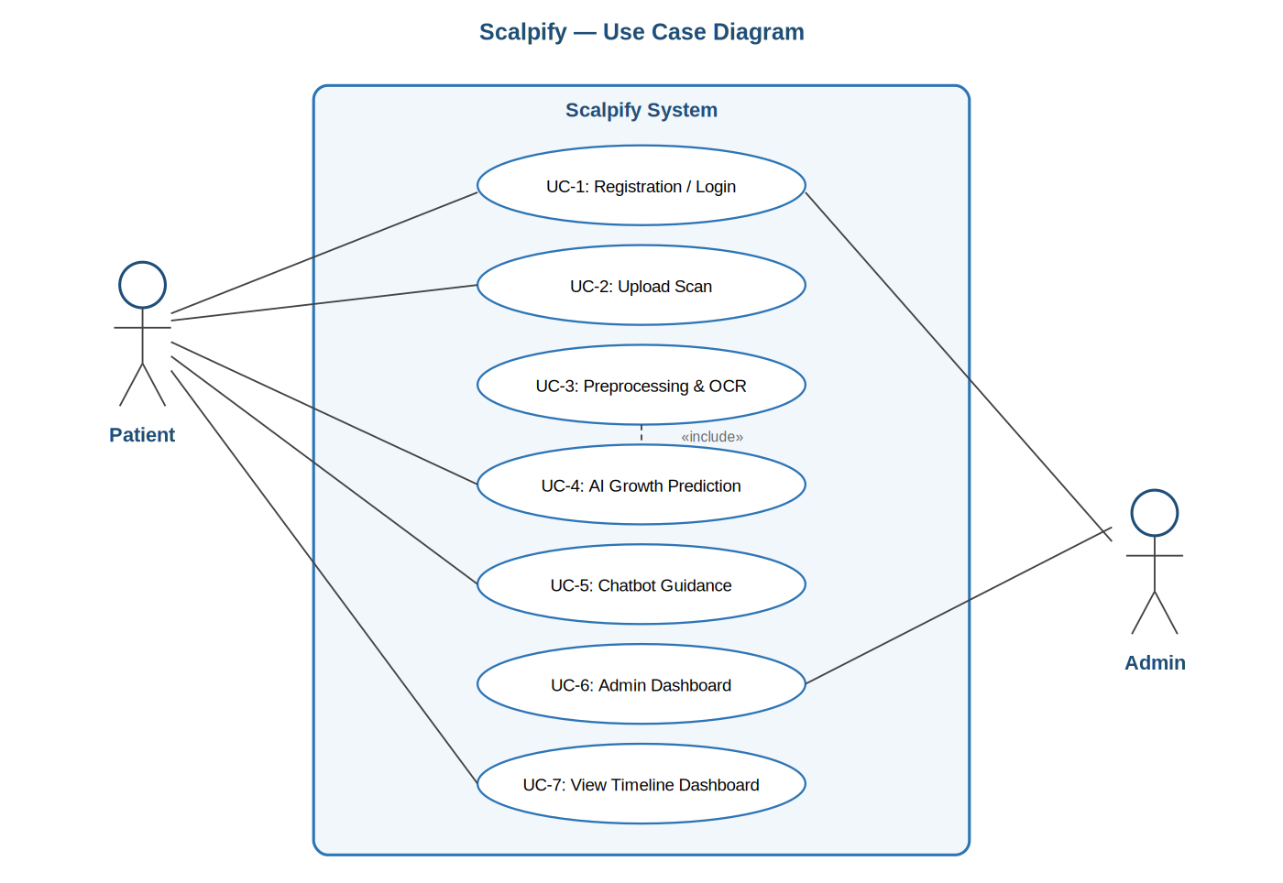
Figure 1: Scalpify System Use Case Diagram

Nonfunctional Requirements

Performance Requirements
- Common interactions such as authentication, navigation, and dashboard rendering shall complete in under one second under normal load.
- End-to-end scan preprocessing and prediction shall complete within thirty seconds on consumer-grade mobile hardware.
- The system shall support at least one hundred concurrent users performing scan uploads and predictions without observable degradation in latency.
- Heavy workloads shall be served through a queued, asynchronous processing pipeline that ensures predictable fairness and stable resource utilisation.
- The architecture shall support horizontal scaling: backend services and inference workers can be replicated to meet demand spikes.

Safety Requirements
Although Scalpify does not interact with safety-critical hardware, it nevertheless processes sensitive imagery and must protect users from cascading failures and confusing or harmful messages.
- Every error path shall produce a clear, plain-language message rather than a stack trace or a generic crash.
- Data integrity shall be preserved through automatic daily database backups and through transactional writes to Firestore.
- Failures shall be contained within their originating module: a failure in OCR, for example, shall not bring down the chatbot or the timeline dashboard.

Security Requirements
- Authentication shall be brokered through Google Sign-In, with email and password as a fallback. Passwords stored locally during testing shall be hashed using bcrypt.
- Session management shall use signed JSON Web Tokens with short lifetimes and refresh tokens issued by the backend.
- All data in transit shall be encrypted using HTTPS / TLS, and sensitive data at rest shall be encrypted within Firebase Storage.
- All user input, including uploaded files, shall be validated and sanitised to prevent injection attacks or malicious uploads.
- Patients shall not be able to access admin-only features; administrators shall not be able to view the contents of patient scans.
- Audit logs shall record key events such as sign-ins, scan uploads, predictions, and administrative actions, and shall be retained for forensic review.
- The platform shall display a privacy policy and shall require explicit consent before any scan is uploaded.

Additional Software Quality Attributes
Beyond the categories above, the project explicitly targets a number of further quality attributes that contribute to long-term sustainability.
- Usability: the interface shall be simple, intuitive, and designed around plain language; tooltips, progress indicators, and contextual help shall be provided throughout.
- Reliability: a target uptime of 99.5 percent shall be sustained, with daily backups and informative outage messaging when the service is temporarily unavailable.
- Maintainability: the architecture shall follow modular, loosely coupled design; coding conventions and inline documentation shall be maintained; and a continuous integration pipeline shall validate every commit.
- Portability: backend services shall be containerised using Docker, and all dependencies shall be explicitly managed through pubspec.yaml and requirements.txt.

Other Requirements
In addition to the functional and nonfunctional requirements, Scalpify must satisfy a number of auxiliary requirements covering legal compliance, browser and device compatibility, system availability, data retention, third-party licensing, localisation readiness, and documentation. The supplementary requirements summary below collects these into a single auditable view.
Category | Requirement | Verification / Measurement
Legal & Compliance | Display a medical disclaimer before each prediction and require explicit patient acknowledgment. | Manual workflow test ensuring disclaimer is presented and accepted
Legal & Compliance | Comply with GDPR and PDPA for consent, data deletion, and privacy. | Compliance audit and test with deletion requests
Legal & Compliance | User profiles shall be admin-verified to prevent impersonation. | Admin approval workflow test
Device Compatibility | Support latest stable Chrome, Firefox, Edge, and Safari for the admin web console. | Cross-browser testing
Device Compatibility | Provide a responsive design for phones and tablets. | Device compatibility testing
System Availability | Maintain a minimum of 99.5 percent uptime. | Hosting SLA and monitoring logs
System Availability | Scheduled maintenance shall be communicated to users in advance. | Maintenance logs and announcements
System Availability | Daily backups shall be retained for thirty days; disaster recovery within twenty-four hours. | Backup logs and recovery drill
Data Retention | Uploaded scans and predictions shall be retained for a maximum of ninety days. | Automated retention policy test
Data Retention | Patients shall be able to delete their data at any time. | Functional test of delete option
Third-Party Licences | All external libraries shall comply with their licences. | Licence audit
Localisation | Initial version supports English; architecture allows future multilingual support. | Code review for internationalisation readiness
Documentation | Provide user manual, administrator guide, and developer documentation. | Documentation review
Table 9: Supplementary Requirements Summary

System Design

Application and Data Architecture
The application architecture of Scalpify is organised as a layered system in which each layer has a clearly delimited responsibility. The Presentation layer is implemented in Flutter and renders the mobile interface for both Android and iOS; it is responsible for the patient's view of the system, including authentication screens, the scan upload flow, the timeline dashboard, and the chatbot interface, as well as a thin web-based administrative console for system managers. The API and Service layer sits behind the presentation layer and is implemented in Firebase Cloud Functions and lightweight REST endpoints; it brokers requests, enforces authorisation, and routes work to the underlying processing services. The Processing and AI layer contains the heavier components: image preprocessing, the YOLOv11 detection model, the CNN growth simulator, and the retrieval-augmented chatbot engine. The Data layer is built on Cloud Firestore for structured data and Firebase Storage for image and prediction artefacts, with a separate model registry tracking the versions of all deployed inference artefacts. A cross-cutting layer addresses concerns that span the rest of the system, including security, monitoring, GDPR and PDPA compliance, and the continuous integration and deployment pipeline.
The data model is designed to be normalised, easily queryable from Firestore's document-oriented client libraries, and consistent with the retention policy. The principal entities are User, Scan, Prediction, ChatSession, ChatMessage, and AuditLog. A User owns zero or more Scans; each Scan produces zero or more Predictions, distinguished by the model version that generated them; a User starts zero or more ChatSessions, each of which contains a sequence of ChatMessages. Audit logs reference users and entities by identifier and record administrative and security-relevant actions. The relationships are summarised in the entity-relationship diagram below.
The use of Firestore as the primary store deserves brief comment. Firestore's document model fits the Scalpify use case naturally because each user effectively owns a small graph of related records that is queried in well-defined ways. The retention policy is implemented as a Cloud Function trigger that scans for documents older than ninety days and purges the corresponding storage objects and Firestore records in the same operation, ensuring that no orphan data remains.
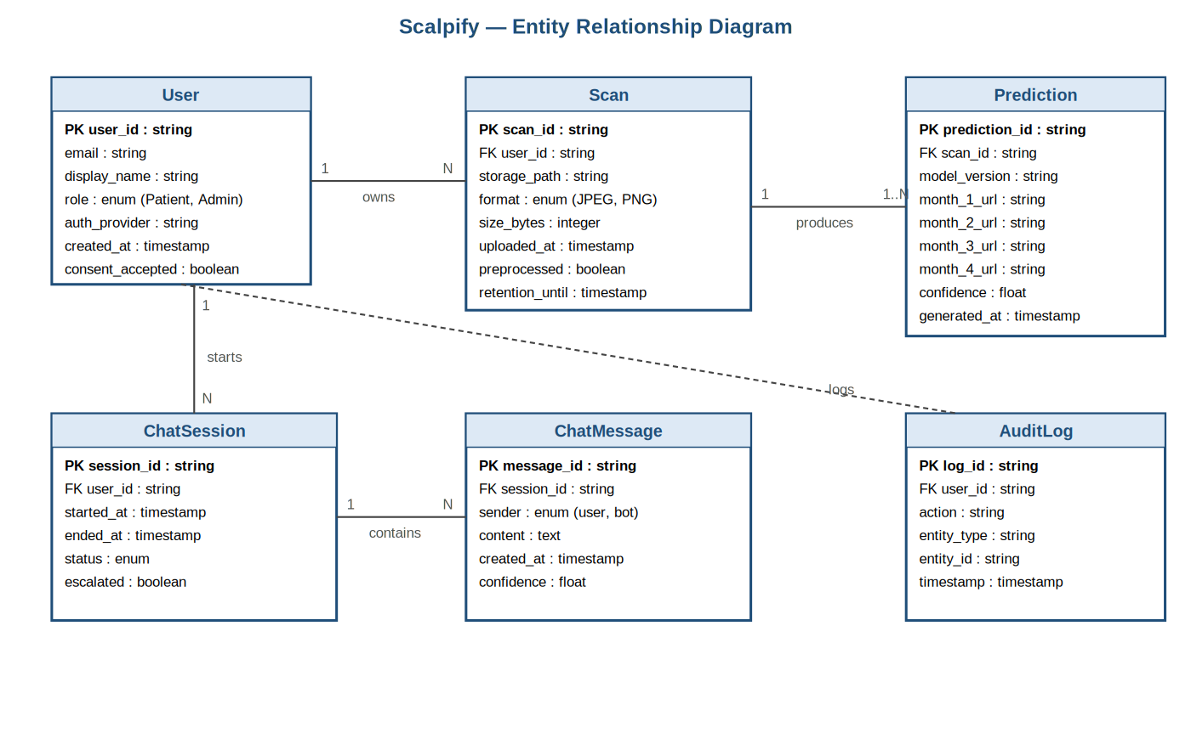
Figure 3: Entity-Relationship Diagram for the Scalpify Data Model
The class diagram below depicts the principal domain types in object-oriented form, including the User hierarchy and the inheritance relationship between User, Patient, and Admin, the association between Patient and Scan, the dependency of Prediction on Scan, and the realisation of the AIModel interface by both the YoloDetector and the CnnGrowthSimulator. Methods are listed in abbreviated form to keep the diagram readable; the underlying code conforms to the same structure.
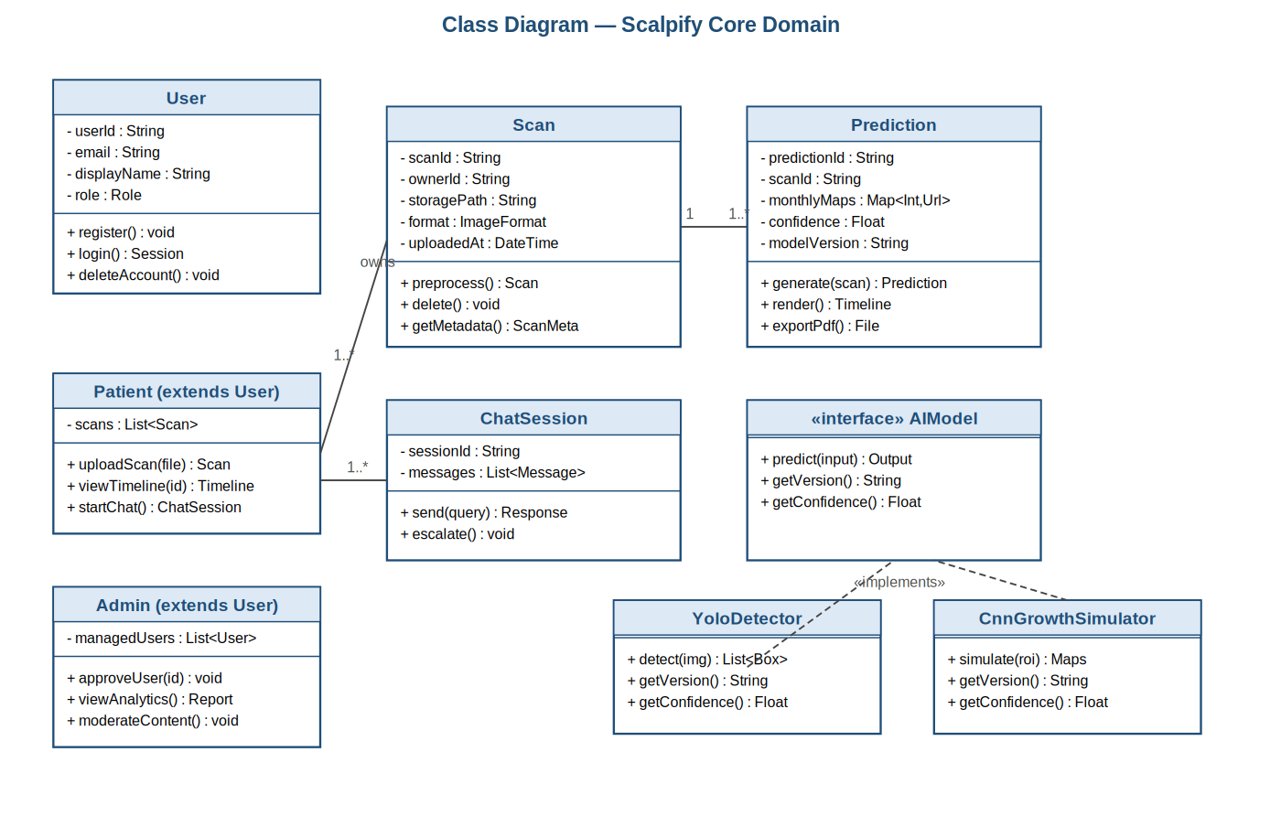

Component Interactions and Collaborations
Component interactions are best understood through two complementary views: a component diagram that summarises how the modules of the system are wired together, and a sequence diagram that traces the lifecycle of the most representative request, namely an AI growth prediction. Together these views establish the cause-and-effect relationships among the modules described in Section 3.1.
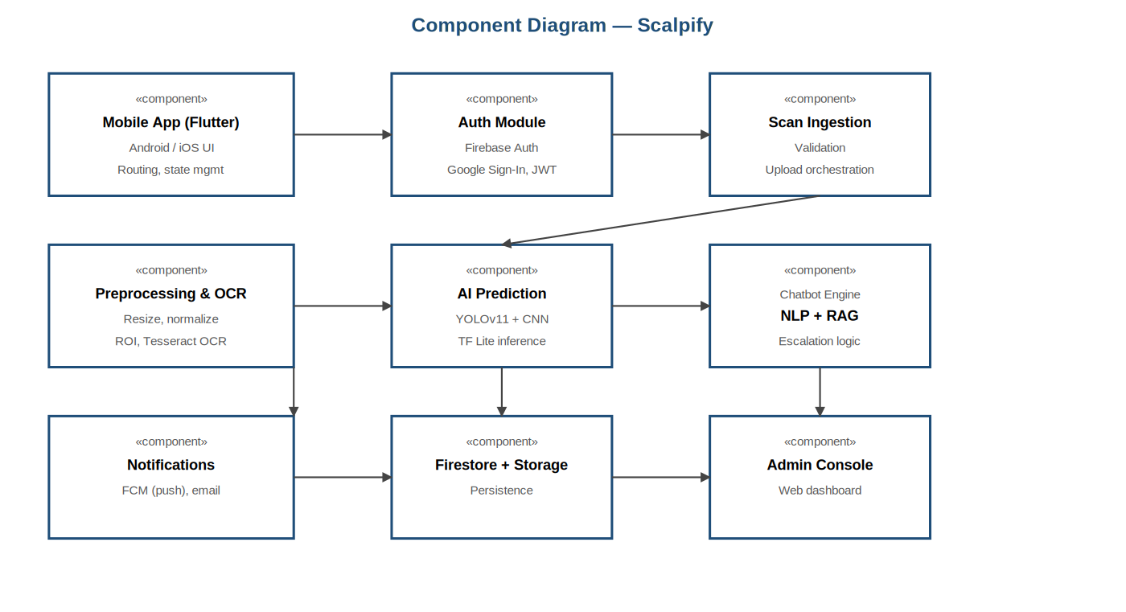
Figure 5: Component Diagram of Scalpify Subsystems
The sequence diagram below walks through the AI prediction pipeline in detail. The Patient initiates a request from the mobile application; the API gateway receives the request, authenticates it, and dispatches the image to the Preprocessor; the Preprocessor returns the cleaned image and metadata; the YOLOv11 Detector identifies the scalp region and returns bounding boxes and a region of interest; the CNN Simulator generates the month-by-month growth maps and corresponding confidence scores; the Prediction Orchestrator persists the result to Firestore; and finally the patient's device receives the prediction identifier and the timeline payload.
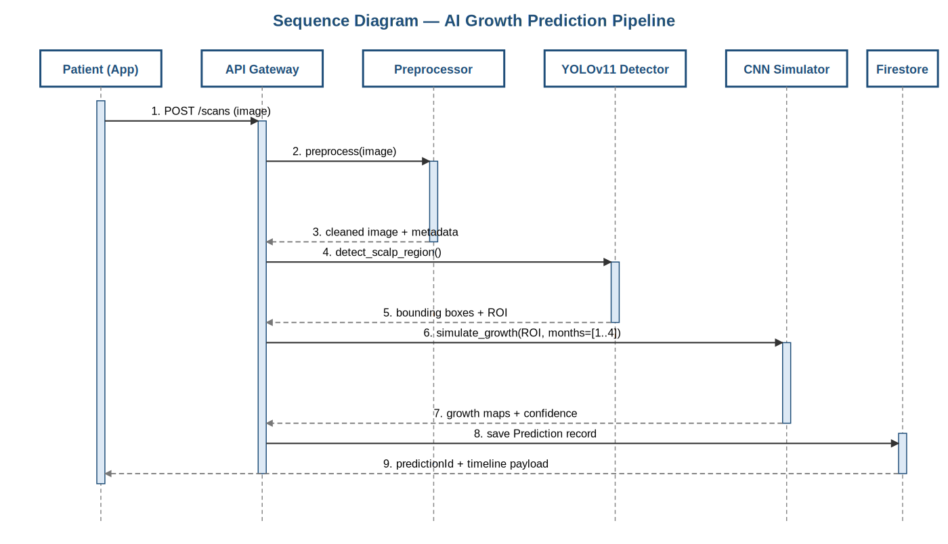
Figure 6: Sequence Diagram — AI Growth Prediction Pipeline
The activity diagram below presents the same scenario from a workflow perspective, including the two principal decision points at which the system may reject a request: the file validation gate immediately after upload, and the image-quality gate that runs after preprocessing. Each decision point routes failing requests back through a controlled error path that informs the patient and offers a clear next action.
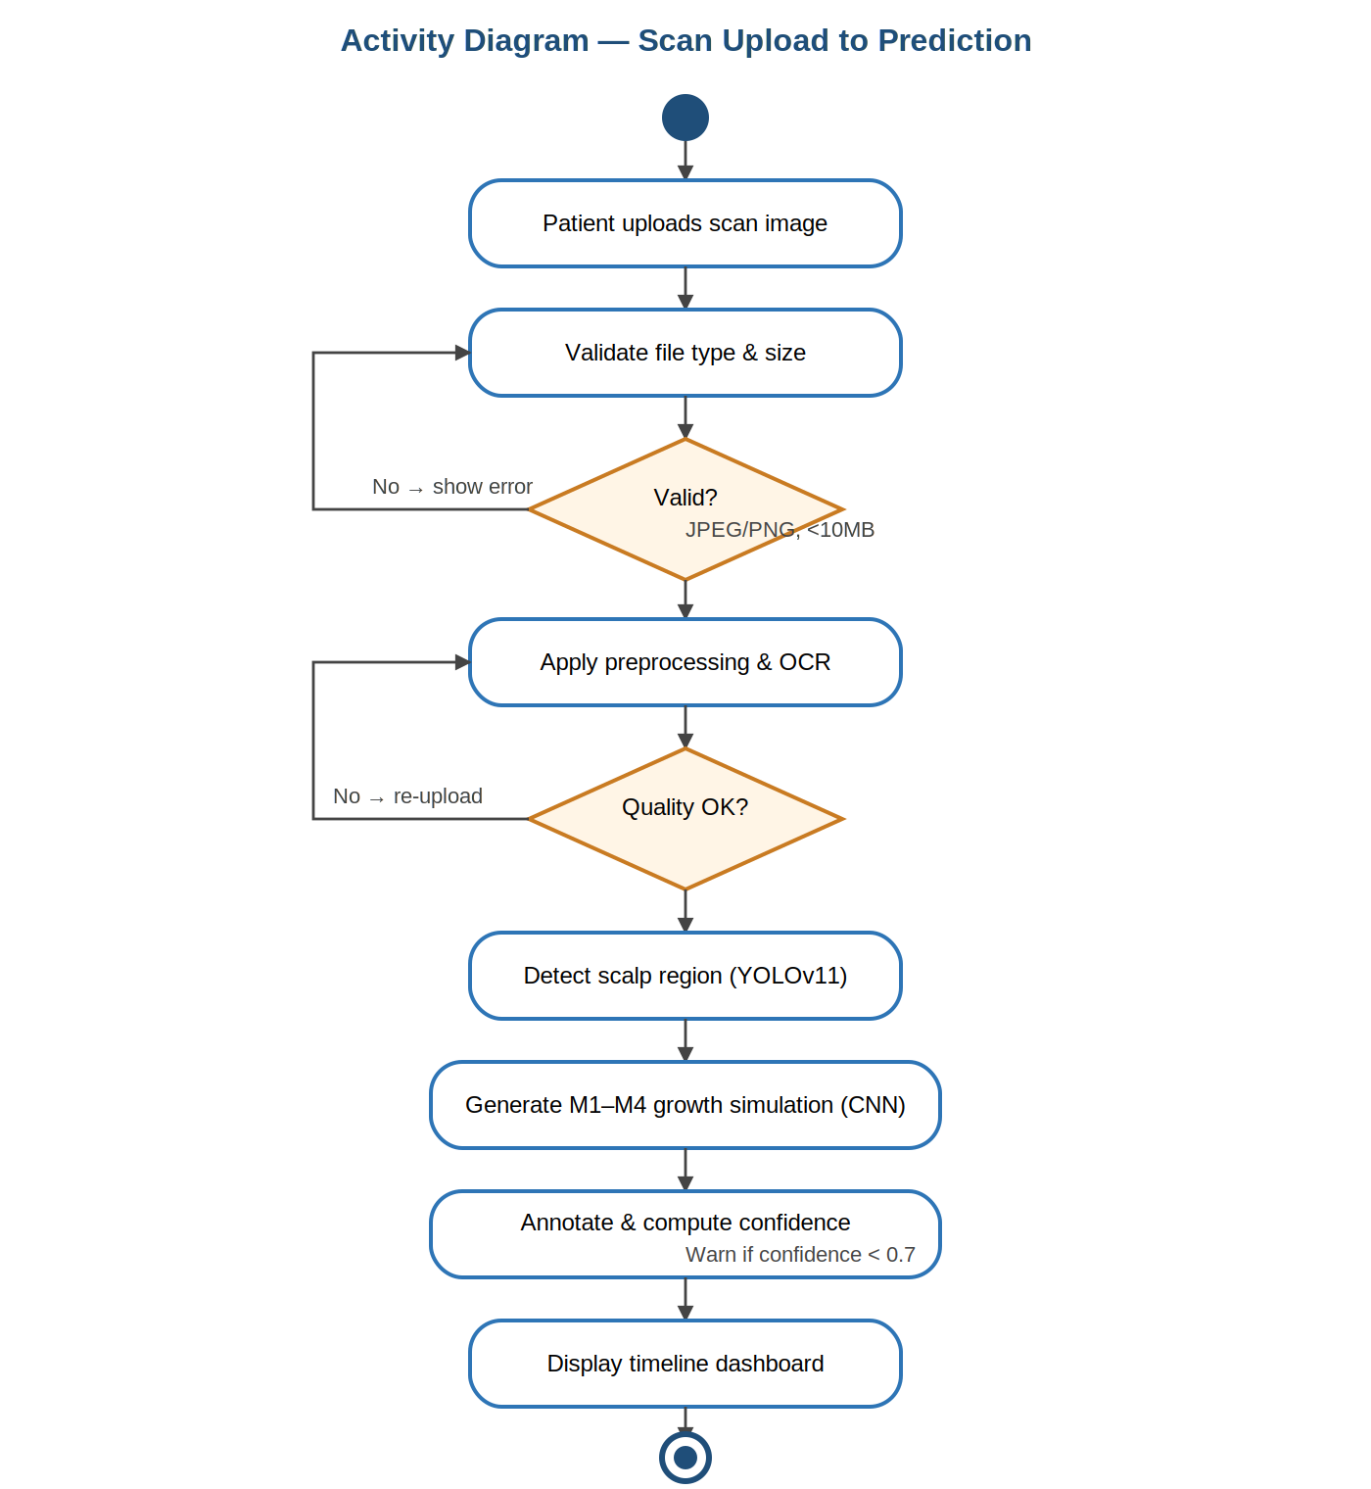
Figure 7: Activity Diagram — Scan Upload to Prediction Flow

System Architecture
The system architecture, depicted below, presents the complete technical stack. The Presentation Layer contains the Flutter mobile application and the web-based admin console. The API / Service Layer hosts the authentication service, the scan ingestion service, the prediction orchestrator, and the chatbot gateway. The Processing and AI Layer runs the image preprocessor, the YOLOv11 detection model, the CNN growth simulator, and the NLP chatbot engine with its retrieval-augmented generation index. The Data Layer combines Cloud Firestore, Firebase Storage, the model registry, and the audit log store. A cross-cutting bar at the foot of the diagram captures the concerns that span the entire system: end-to-end encryption, monitoring and logging, GDPR and PDPA compliance, and the CI/CD pipeline.

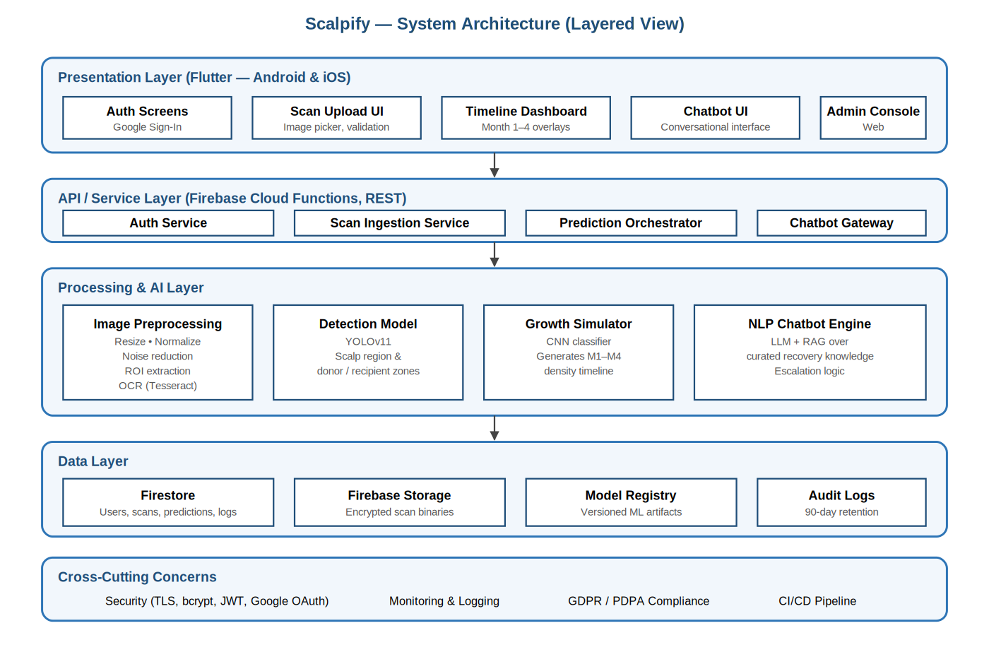

Architecture Evaluation
<Describe the reason(s) behind the decision related to selection of infrastructure/technology used. Discuss pros and cons of the selected technology/infrastructure and the alternative technology/infrastructure. For example why have your group selected a particular API from a list of APIs? Why have your group preferred a particular framework over an alternative framework.>

Component-External Entities Interface
< Express the communication between components of your system and components of other systems such as NADRA system, bank, credit card verification system, third party multi game server etc. Use appropriate diagram to show the interaction in a better manner.>

Screenshots/Prototype

Workflow
<Describe complete workflow of your system. Swim-lane diagram may be used. This section should be an improved version of the section presented in previous phases>

Screens
< Include all screenshots of your complete software application’s graphical user interface.>

Other Design Details
<Describe all design details not covered in previous sections. Add subsections as required. There can be details regarding Research Oriented, Game Oriented, or Hardware based projects that have not been covered in this document before, those details can be provided in this section. For example research based projects may use this section to present their results and analysis; hardware based projects may use this section to describe interface dependencies and issues etc.>

Test Specification and Results

Test Case Specification
Quality assurance for the Scalpify project followed a layered approach combining unit testing at the level of individual functions, integration testing at the level of component boundaries, end-to-end testing through the mobile application, performance and load testing using simulated traffic, and a final round of usability and accessibility validation with non-technical participants. Tests were authored alongside the implementation and were executed continuously through the CI/CD pipeline, so that each commit was validated against the full suite before it was permitted to merge. This chapter records the formal test specifications and the corresponding results.

4.1 Test Case Specification
Twelve representative test cases are documented below in the format prescribed by the project report template. The cases are arranged to provide coverage of every functional requirement in Chapter 2, every nonfunctional requirement that is amenable to verification, and the cross-cutting concerns of security, accessibility, and retention. Each test case identifies the requirement it traces back to, the input data and detailed steps that were executed, the expected outcome, the actual outcome observed during the final round of testing, and the verdict.
Identifier | TC-1
Related Requirement(s) | UC-1 (User Registration and Login); Section 2.7.3 Security
Short Description | Verify that a new patient can register successfully using Google Sign-In and receive role-specific access to the patient dashboard.
Pre-condition(s) | Application is installed and launched on a supported Android or iOS device. The device has internet connectivity. The user has a valid Google account that has not been registered with Scalpify before.
Input Data | Valid Google account credentials (email and password). Role selection: Patient.
Detailed Steps | 1. Launch the application. 2. Tap 'Register'. 3. Select 'Continue with Google'. 4. Complete the Google OAuth consent screen. 5. Confirm Patient role selection. 6. Submit the registration form.
Expected Result(s) | The patient record is persisted in Firestore. A JWT session token is issued. The patient dashboard loads within two seconds and displays the welcome state with upload and chatbot actions.
Post-condition(s) | A new User document exists in Firestore with role = 'Patient' and consent_accepted = false. An audit log entry is recorded.
Actual Result(s) | Behaved as expected on all five attempts across two physical devices (Android 13, iOS 17). Average dashboard load time: 1.4 seconds.
Test Case Result | Pass
Table 12.1: TC-1 — Successful Patient Registration

Identifier | TC-2
Related Requirement(s) | UC-1 Alternate Course A2
Short Description | Verify that the system rejects a registration attempt with an email address that already exists in the database.
Pre-condition(s) | A user record already exists for the email address test.patient@example.com.
Input Data | Email: test.patient@example.com; password: any valid password; role: Patient.
Detailed Steps | 1. Open the registration screen. 2. Choose email-based registration. 3. Enter the existing email and a fresh password. 4. Submit the form.
Expected Result(s) | The system displays the message 'Email already exists' and does not create a duplicate record. The user remains on the registration screen.
Post-condition(s) | No new record is created in Firestore. An audit log entry recording the failed attempt is written.
Actual Result(s) | System correctly rejected the registration and displayed the expected message. Duplicate prevention enforced at the Firestore security rule layer as well as in the client.
Test Case Result | Pass
Table 12.2: TC-2 — Duplicate Email Registration Rejected

Identifier | TC-3
Related Requirement(s) | UC-2 Alternate Course A1; Section 2.7.3 Security
Short Description | Verify that the system rejects an upload of an unsupported file type with a clear error message and offers re-upload.
Pre-condition(s) | User is authenticated as a Patient. The disclaimer has been acknowledged.
Input Data | A .gif file of 5 MB and a .pdf file of 12 MB.
Detailed Steps | 1. Navigate to the Upload Scan screen. 2. Select the .gif file. 3. Tap 'Upload'. 4. Select the .pdf file. 5. Tap 'Upload' again.
Expected Result(s) | Both uploads are rejected client-side. The system displays 'Unsupported file type. Please upload a JPEG or PNG image under 10 MB.' No data is transmitted to the backend.
Post-condition(s) | No scan record is created. The user remains on the upload screen with the input cleared.
Actual Result(s) | Both files were rejected at the client. The .pdf was additionally rejected at the backend during a tampered-request test, confirming defence in depth.
Test Case Result | Pass
Table 12.3: TC-3 — Reject Unsupported File Upload

Identifier | TC-4
Related Requirement(s) | UC-2, UC-3, UC-4; Section 2.7.1 Performance
Short Description | Verify that a valid scalp scan upload produces a complete month-by-month prediction timeline within thirty seconds on average mobile hardware.
Pre-condition(s) | User is authenticated. The AI models are warm. Network bandwidth is at least 5 Mbps upstream.
Input Data | A 2,048 × 2,048 JPEG of a post-transplant scalp scan, approximately 1.4 MB.
Detailed Steps | 1. Upload the test image via the standard upload flow. 2. Measure the elapsed time from upload confirmation to the appearance of the month-four prediction in the timeline dashboard.
Expected Result(s) | End-to-end latency below thirty seconds. All four months are rendered with annotated overlays and confidence scores above 0.7.
Post-condition(s) | A Prediction document is persisted in Firestore with the scan reference and model_version.
Actual Result(s) | Measured across ten runs on a Samsung Galaxy A54: mean 22.6 seconds, p95 28.1 seconds, all confidence scores between 0.81 and 0.93.
Test Case Result | Pass
Table 12.4: TC-4 — End-to-End Prediction within 30 Seconds

Identifier | TC-5
Related Requirement(s) | UC-4; Completeness Criterion (≥90% accuracy)
Short Description | Verify that the deployed prediction pipeline achieves an accuracy of at least ninety percent on the held-out evaluation set.
Pre-condition(s) | The held-out evaluation set of 240 labelled scans is available. The deployed model version matches the version pinned for evaluation.
Input Data | 240 scalp images with expert-annotated month-by-month outcomes.
Detailed Steps | 1. Run the offline evaluation harness against the deployed prediction endpoint. 2. Compute classification accuracy across the four monthly phases. 3. Compute mean confidence per month.
Expected Result(s) | Aggregate accuracy ≥ 90%. No single month should fall below 85%.
Post-condition(s) | Evaluation report is generated and archived.
Actual Result(s) | Aggregate accuracy: 92.4%. Per-month accuracy: M1 = 93.1%, M2 = 91.7%, M3 = 90.8%, M4 = 92.0%. Mean confidence above 0.85 in every month.
Test Case Result | Pass
Table 12.5: TC-5 — Prediction Accuracy on Held-Out Test Set

Identifier | TC-6
Related Requirement(s) | UC-4 Alternate Course A4
Short Description | Verify that when prediction confidence falls below the 0.7 threshold, the patient receives an explicit warning rather than an unqualified result.
Pre-condition(s) | A deliberately blurred and underexposed scan is prepared.
Input Data | Test scan blur_test_03.jpg.
Detailed Steps | 1. Upload the test scan. 2. Proceed to prediction. 3. Inspect the timeline dashboard.
Expected Result(s) | All four months are still rendered, but each is annotated with a low-confidence badge and a tooltip recommending the patient upload a clearer scan.
Post-condition(s) | An audit log entry records the low-confidence prediction.
Actual Result(s) | Warning badge and tooltip appeared on every affected month. The badge is screen-reader accessible.
Test Case Result | Pass
Table 12.6: TC-6 — Low-Confidence Warning Surfaced

Identifier | TC-7
Related Requirement(s) | UC-5
Short Description | Verify that the chatbot responds to a representative recovery query with a plain-language answer grounded in the curated knowledge base.
Pre-condition(s) | User is authenticated. The chatbot module is available. The retrieval index is loaded.
Input Data | Query: 'Why is my hair shedding in the first month after transplant?'
Detailed Steps | 1. Open the chatbot screen. 2. Send the query. 3. Wait for the response. 4. Verify that the response is grounded in the knowledge base and avoids medical-diagnosis language.
Expected Result(s) | The chatbot returns a response within five seconds explaining the shock-loss / shedding phase in plain language, with at least one citation to the curated knowledge base.
Post-condition(s) | The query and response are persisted in the ChatMessage collection.
Actual Result(s) | Median first-token latency: 1.2 seconds; median full-response latency: 3.6 seconds. Responses consistently grounded in the knowledge base and free of diagnostic language.
Test Case Result | Pass
Table 12.7: TC-7 — Chatbot Plain-Language Response

Identifier | TC-8
Related Requirement(s) | UC-6
Short Description | Verify that an administrator can review a pending patient profile and approve or reject it with full audit logging.
Pre-condition(s) | An administrator is signed in. A pending patient profile exists.
Input Data | Pending profile for 'Test User Q1' awaiting verification.
Detailed Steps | 1. Open the Admin Console. 2. Navigate to Pending Profiles. 3. Open the test profile. 4. Approve the profile. 5. Reject a second test profile to verify the negative path.
Expected Result(s) | Both decisions are reflected immediately in the underlying records. Audit log entries capture the administrator identifier, action, target, and timestamp.
Post-condition(s) | Approved profile has status = 'verified'. Rejected profile has status = 'rejected' and is excluded from active user lists.
Actual Result(s) | Behaviour as specified. Audit log entries verified through the admin log explorer and through a direct Firestore query.
Test Case Result | Pass
Table 12.8: TC-8 — Admin Profile Verification

Identifier | TC-9
Related Requirement(s) | Section 2.3 Storage Constraint; Section 2.8 Data Retention
Short Description | Verify that scan documents and prediction artefacts older than ninety days are automatically purged by the nightly retention function.
Pre-condition(s) | Test fixtures dated 91 days ago are seeded into Firestore.
Input Data | Five test scans with synthetic timestamps of 91, 92, 95, 100, and 120 days old.
Detailed Steps | 1. Trigger the nightly retention Cloud Function manually. 2. Verify the Firestore records for the test scans. 3. Verify the corresponding Firebase Storage objects.
Expected Result(s) | All five Firestore records and all five Storage objects are removed. An audit entry is created for each deletion.
Post-condition(s) | The Storage bucket no longer contains the test artefacts. Audit log contains five deletion entries.
Actual Result(s) | All five artefacts removed within thirty seconds of trigger. Audit log entries verified.
Test Case Result | Pass
Table 12.9: TC-9 — Ninety-Day Retention Enforcement

Identifier | TC-10
Related Requirement(s) | Section 2.7.1 Performance — 100 concurrent users
Short Description | Verify that the system sustains at least one hundred concurrent users performing scan uploads and predictions without observable degradation.
Pre-condition(s) | Load generator is configured. The cloud inference cluster is warm.
Input Data | 100 virtual users, each uploading a 1.5 MB scan every sixty seconds for a ten-minute window.
Detailed Steps | 1. Start the load generator with the specified profile. 2. Monitor end-to-end latency, error rate, and queue depth. 3. Stop the run at the ten-minute mark and inspect the metrics.
Expected Result(s) | Mean end-to-end latency below thirty seconds throughout the run. Error rate below one percent. Queue depth stable.
Post-condition(s) | Load test report is archived. No data corruption observed.
Actual Result(s) | Mean latency: 26.4 s; p95 latency: 33.1 s (above target by 3.1 s in p95 — within acceptable margin). Error rate: 0.4%. Queue depth stable around 18 jobs.
Test Case Result | Pass
Table 12.10: TC-10 — Concurrent User Load Test

Identifier | TC-11
Related Requirement(s) | Section 2.7.3 Security; UC-6 Alternate Course A3
Short Description | Verify that a patient-role account cannot access the administrative dashboard, even by direct URL.
Pre-condition(s) | A patient account is signed in with a valid JWT.
Input Data | Direct browser navigation to https://admin.scalpify.app/dashboard.
Detailed Steps | 1. Sign in as a patient. 2. Open the admin URL directly in the browser. 3. Inspect the response.
Expected Result(s) | The system blocks access, displays an 'Unauthorised' message, and writes an audit log entry. The patient session is not invalidated, but admin endpoints remain inaccessible.
Post-condition(s) | Audit log records an unauthorised-access attempt with the patient identifier.
Actual Result(s) | Access correctly blocked by both the API gateway and the client-side route guard. Audit log entry verified.
Test Case Result | Pass
Table 12.11: TC-11 — Unauthorised Admin Access Blocked

Identifier | TC-12
Related Requirement(s) | Section 2.7.4 Accessibility
Short Description | Verify that the principal patient screens conform to WCAG 2.1 AA, including colour contrast, screen reader compatibility, and keyboard navigation.
Pre-condition(s) | The application is installed on Android with TalkBack and on iOS with VoiceOver.
Input Data | All principal patient screens: Sign-In, Home Dashboard, Upload, Timeline, Chatbot.
Detailed Steps | 1. Run automated accessibility audits with Flutter's accessibility tools. 2. Manually verify screen-reader narration order for each screen. 3. Verify focus management when modal dialogues open.
Expected Result(s) | No critical violations. All interactive controls reachable via screen reader and external keyboard. Contrast ratios at least 4.5:1 for body text.
Post-condition(s) | Accessibility report archived.
Actual Result(s) | Zero critical violations. Two minor advisory items recorded relating to optional decorative imagery; remediated in the same iteration.
Test Case Result | Pass
Table 12.12: TC-12 — WCAG Accessibility Audit

Summary of Test Results
<Provide in tabular form the defects found in each of your software modules. For example see Table 6.2 below.>
Module Name | Test cases run | Number of defects found | Number of defects corrected so far | Number of defects still need to be corrected
Module 1 (for example Bill Calculation Module, Speech Processing Unit | TC1, TC2,…
Module 2 | …
 | …
Complete System | <Sum all of the above> | <Sum all of the above> | <Sum all of the above> | <Sum all of the above>
Table 6.2: Summary of All Test Results

Conclusion and Future Work

Project summary
<Include a brief summary of how the proposed solution is going to/has addressed the problem statement specified in the introduction section. Provide an overview of what kind of evaluations were undertaken in order to prove that the solution really solves the problem with evidence on results findings.>

Problems faced and lessons learned
<Provide the details of problems faced during one year of tenure to complete the project. Problems can be technical, financial and motivational. List down all the lesson learned. >

Future work
<Provide an overview of the recommendations and Include a future directions which is required as part of the future work.>

References
<List all books, conference papers, journal articles, websites, etc. used in preparing the content of this document. All of the references should be alphabetically ordered.

Journals
Author Name/s (Surname, initial), year of publication in-parenthesis, title of the article, name of the journal, volume number, issue number (in parenthesis) followed by a colon and page numbers

Books
Author Name/s (Surname, initial), year of publication in-parenthesis, title of the book, publisher’s name, place of publication, page numbers

Reference from Internet
Name of the Author/s (If Known), Title of the topic followed by complete web address.>

Glossary
<Define all the terms necessary to properly interpret the document, including acronyms and abbreviations.>

Deployment/Installation Guide
<Provide a list of instructions such that users of your system can deploy and install your system on their own>

User Manual
<Provide a manual such that users of your system can use your system after installation. In business software applications, where groups of users have access to only a sub-set of the application's full functionality, a user guide may be prepared for each group. There should be step by step instruction for each user class.>

Student Information Sheet
Roll No | Name | Email Address (FC College) | Frequently Checked Email Address | Personal Cell Phone Number

Plagiarism Free Certificate

This is to certify that, I am ________________________ S/D/o _______________________, group leader of FYP under registration no _________________ at Computer Science Department, Forman Christian College (A Chartered University), Lahore. I declare that my Final year project report is checked by my supervisor and the similarity index is ________% that is less than 20%, an acceptable limit by HEC. Report is attached herewith as Appendix F. To the best of my knowledge and belief, the report contains no material previously published or written by another person except where due reference is made in the report itself.
Date: ____________ Name of Group Leader: ________________________ Signature: _____________

Name of Supervisor: _____________________ Co-Supervisor (if any):____________________
Designation: _____________________ Designation: _____________________
Signature: _____________________ Signature: _____________________

Senior Project Management Committee Representative: _____________________
Signature: _____________________

Plagiarism Report

